Lab Objectives

This lab will get you get started with the advance features of Dialogflow. Specifically, you will learn how to enable the fulfillment functionality.

Fulfillment allows an agent to work with a backend system that will perform specific business logic based on the intent data and generate dynamic responses back to the agent. You will also learn to deploy a Python program as a webservices.

Should you get stuck, please reach to out to your trainer.

This lab is comprised of 2 activities.

Nr | Purpose
1 | Environment setup
2 | Deploy a Python webhook to your laptop

Pre-requisites

- Google account
- Internet access
- PC/laptop that runs Windows or mac OS
- Python 3.6 or above environment (DO NOT USE lower versions)
- Ngrok
- Dialogflow concepts like agent, intents, training phrases and parameters.
- Working knowledge of Git and command line operations like changing and listing directory
- Anaconda Navigator
- Git

Activity 1 – Environment Setup (Dialogflow)

In this activity, you will create an agent and import an agent that is partially configured with fulfilment.

The outline for this activity is:
- Create an agent
- Import an agent
- Test a connection to a sample webhook

Setup:
1. | Clone or download the project from github  https://github.com/Ipomoeabatatas/demo-webhook-python
2. | - Open a windows terminal.  - Change directory to a suitable project folder  - Enter the command:  Git clone https://github.com/Ipomoeabatatas/demo-webhook-python.git  You should see a new directory created.  Change to the new directory.

1. | In Dialogflow, create a new agent.
2. | Import the demo agent:  - Select the gear icon next to the agent name.  - Select Export and Import Tab  - Click on IMPORT FROM ZIP  - Click on SELECT FILE and upload the given agent file (DemoWebhookAgent.zip) that was clone or download from Github
3. | Setup the basic fulfilment settings:  - Navigate to Fulfilment.  - Enter the URL path as given by the instructors  - Toggle the button to enable fulfilment.  - Select SAVE.
4. | In the test console, enter the expression “test connection”. You should see an output that is similar to the image below.  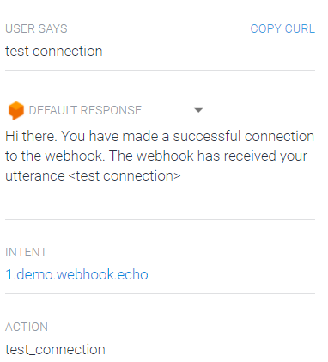

Congratulations. You can use this agent for the subsequent activities.

Activity 2 – Deploy a python webhook in your local environment.

In the previous activity, you have learned to enable the fulfillment feature of an agent and connect to an existing webhook. In this activity, you will replicate a working webhook program onto your laptop.

The outline for this activity is:
- Use Flask to run a Python app as a web service in the local environment
- Use ngrok to create a tunnel back to your local host such that Dialogflow can make a http request to it
- Configure the settings in Dialogflow to enable fulfillment via webhook

Setup: You should have Anaconda Navigator install and have a Python 3.6 environment define.

1. | Launch Anaconda Navigator.
2. | Within Anaconda Navigator, select the environment (Python 3.6) that you have prepared and select Open Terminal.  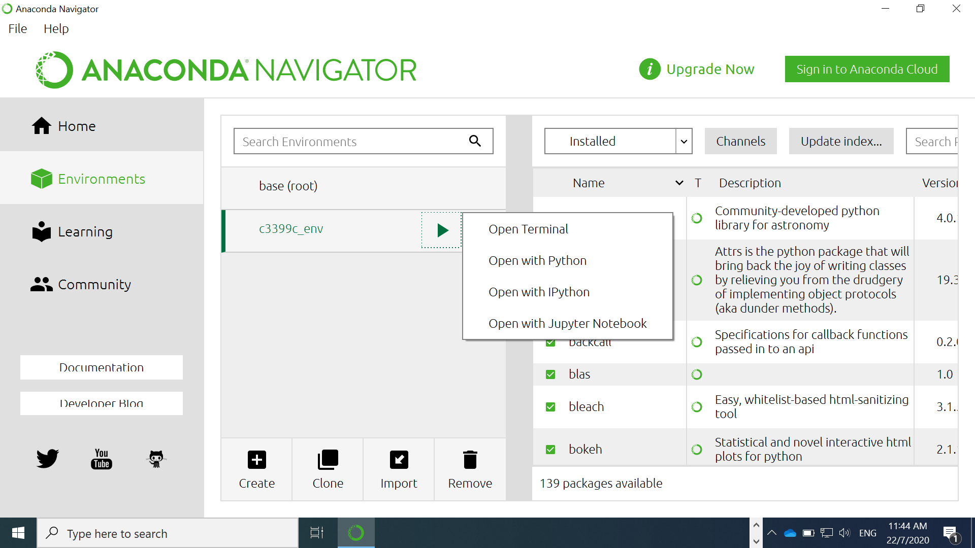
3. | Within the terminal window, change to the folder containing the clone project.  In the directory, enter the command:  pip install -r requirements.txt  (Note: Do the pip install once only)
4. | If you are using Windows, execute the following commands:  set FLASK_APP=index.py  set FLASK_ENV=development  flask run  If you are using Mac, execute the following commands:  export FLASK_APP=$(PWD)/index.py  export FLASK_ENV=development  flask run  You should see an output similar to the image below.  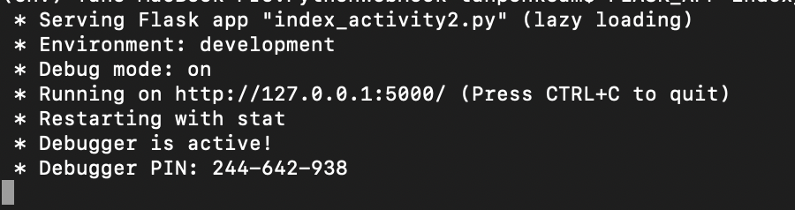
5. | Copy the url (e.g. http://127.0.0.1) into a browser to display a similar message as below. This will indicate that you have deployed the flask app successfully.  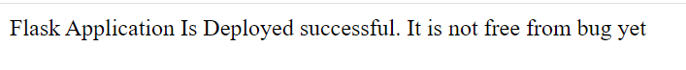
6. | Use the windows search bar to locate ngrok.exe . Do NOT press enter.  - Select the file from the search result.  - Click Open file location.  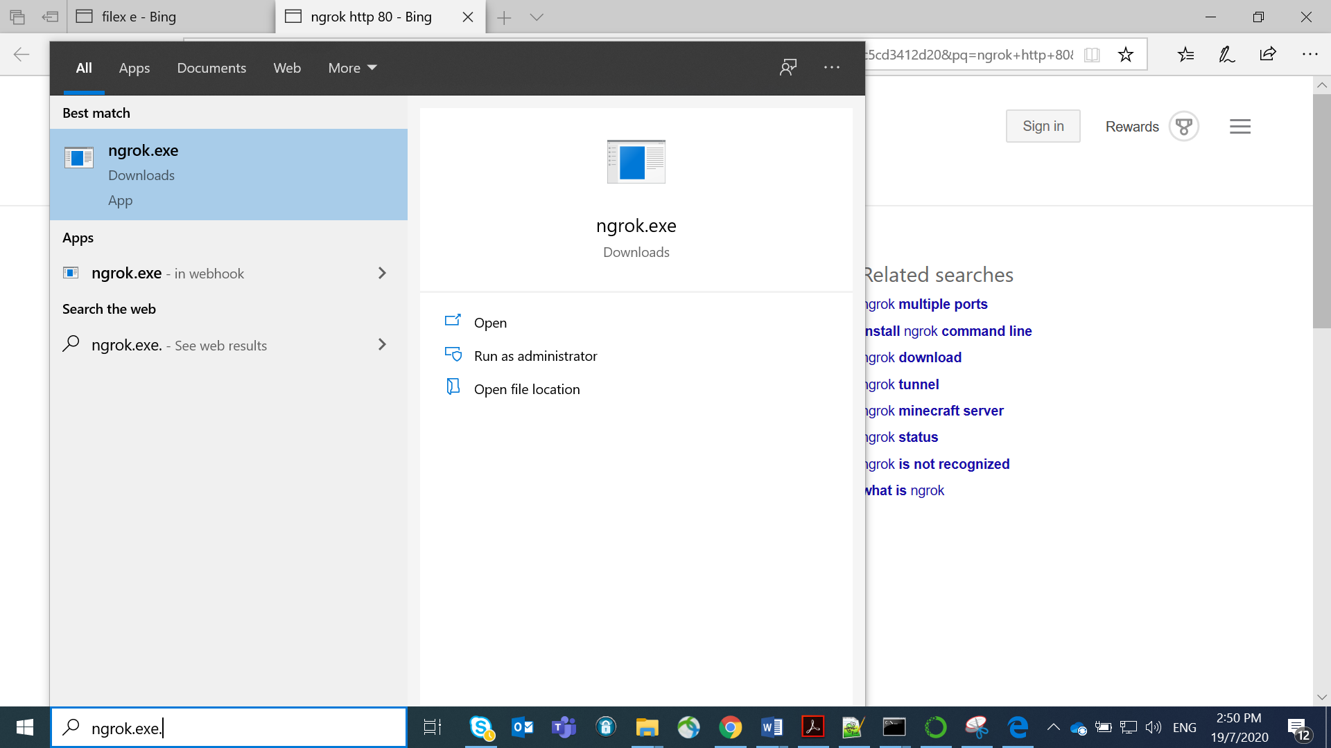
7. | Double click on the file ngrok. You should get a new terminal screen.
8. | In the new terminal window, type the command below.  Mac: ./ngrok http localhost:5000  Windows: ngrok http localhost:5000  You should see an output similar to below.  The forwarding url will tunnel http request to your flask application that is running as a local host.  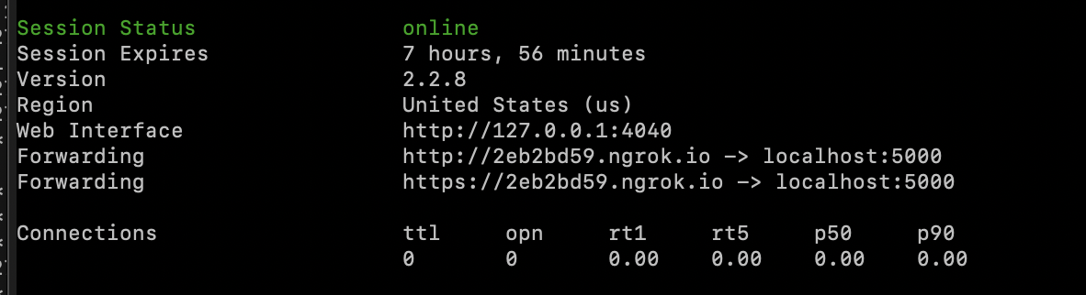
9 | Copy the forwarding url (https).
10. | Return to the Dialogflow agent.  - Navigate to the Fulfillment section.  - Replace the URL with the forwarding url. Check that the URL ends with /webhook. Make sure that there are no spaces.  - Select SAVE  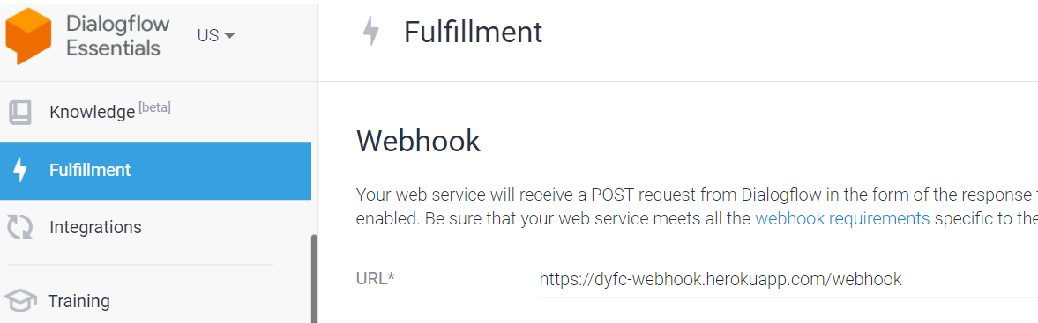

At this stage, you can test the Agent by entering queries. You should be able to see the status of the webhook program being executed from the terminal windows.

If your $PATH does not point the current working directory, you may have to use the full working path. You can find out by typing pwd in Mac

